Claverley Indoor Bowling Club.
Claverley Indoor Bowling Club was formed in 1996 by the late Roland Croucher and his wife Joan who had been playing short mat bowls for many years prior to coming to live in the village.

It is largely due to Roland and Joan that the Club has gone from strength to strength and the membership currently stands at 48.
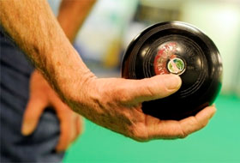
To accommodate the increase in members there are now three sessions which are held every
Wednesday in Claverley Village Hall.
Afternoon Session 2,30pm to 4,30pm
Mid. Session 5.00 pm to 7,00pm
Evening Session 8,00pm to 10,00pm
The season normally runs from October until April with a break for the Christmas celebrations.
In addition, friendly games are arranged with clubs from neighbouring villages, both home and away.
E.g., Alveley, Chelmarsh, Ditton Priors, Pattingham and Worfield.
New members are most welcome with bowls and tuition available if needed.
For further information- telephone John Cotham 01746 710340 or John Parker 01746710592

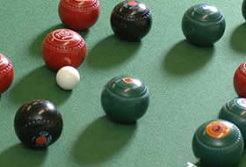
Understanding Short Mat Bowls.
The Players
A game of short mat bowls is contested as either a singles game with 2 players, a doubles match with 2 players on each side, or as a team game with either 3 or 4 players per team, with each player playing with 2 bowls. At Claverley we normally play with 4 players in each team.
The Playing Area.
A game takes place on a long narrow mat called a short mat, which measures 45 feet long and 6 feet wide. A small ball called a jack is placed at one end of the mat, a block of wood is positioned in the centre of the mat across the middle and a delivery mat is placed at the opposite end to the jack.

All of these must be positioned either on or within specific boundaries which are marked out on the mat by a number of white lines.
With one foot on the delivery mat, each opposing player or team will take it in turns to send a bowl and attempt to get as close to the jack as possible. As the block of wood prevents them from playing directly down the centre of the mat, a certain amount of skill is required to avoid hitting it.

Players on opposing sides play their shots alternately until all the bowls have been played by all players. The entire process is called an 'end'
Playing the game.
In games involving more than one person on each side, an order of play is decided for each player on a team. This means that you have a 'lead player' (No 1) for each team who bowls first and a 'skip' who bowls last. If there are 3 or 4 players in each team the additional players are referred to as 'No 2's' and 'No 3's. A 'No 2' cannot bowl until the No 1 players from both sides have delivered all their bowls; and this rule follows for the 'No 3's', and 'skips'.
Scoring
Following the completion of an end, the bowl or bowls adjudged to be the nearest the jack are scored for their respective team.
As an example, if Team A has a bowl which is nearest the jack, but the second nearest bowl belongs to Team B, one point is scored for that end by Team A. However, should Team A have the second, third, fourth etc. placed bowls for that end, then they score an additional point for each bowl.

When the score for that end has been agreed, the jack and delivery mat swap places at each end of the mat and the next end begins; the No 1 from the team that just scored, bowling first.
Once all pre-determined ends have been played, the team with the highest score is declared winner.
That's about it as far as the basics are concerned but there's a whole bunch of other rules such as foot faults, measuring, dead bowls etc, but for now this should give newcomers enough of an understanding to get started. It won't be long before you are into your stride and bowling well.

